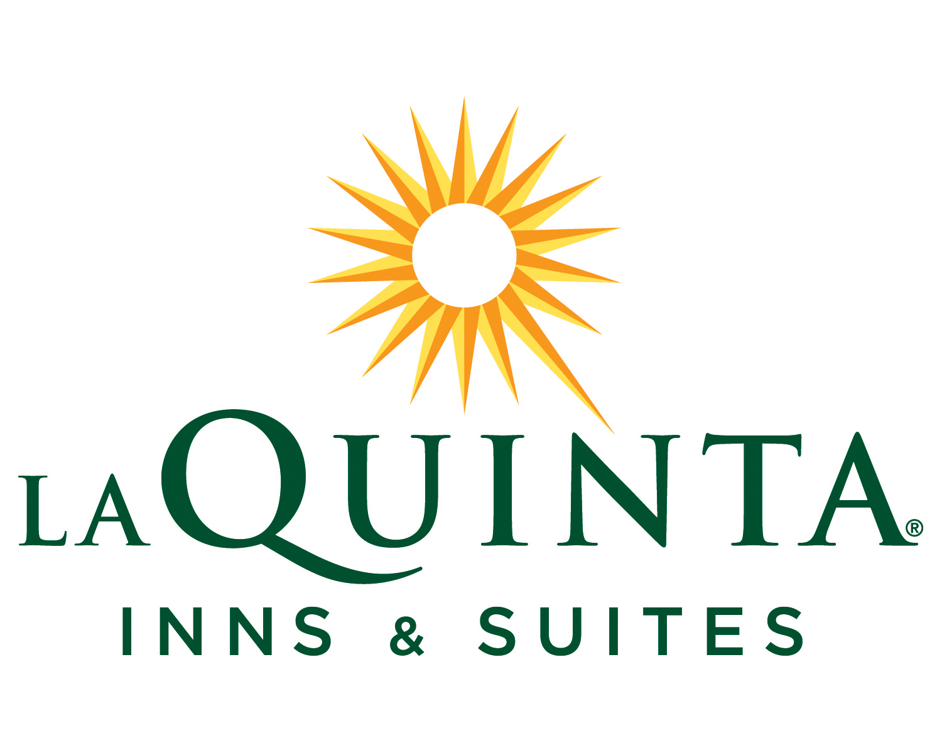
La Quinta Inn & Suites New Haven
400 Sargent Drive
New Haven, CT 06511
(203) 562-1111
RAMESH, NAGESH
48 N.SYCAMORE ST.
MACUNGIE, PA 18062
Company: L
Folio#: 204848016
Room: 506
Arrival: 09/21/08
Departure: 09/26/08
Rate: $112.00
Returns Club No:
Voucher/Ship/PO:

Trans# Date Description Charges Payments Balance

156965 09/21/2008 Rm: 506 Best Avail.Rate $112.00 $0.00 $112.00
156966 09/21/2008 TAX-OCCUPANCY-CITY $6.72 $0.00 $118.72
156967 09/21/2008 TAX-OCCUPANCY-ST $6.72 $0.00 $125.44
157221 09/22/2008 Rm: 506 Best Avail.Rate $112.00 $0.00 $237.44
157222 09/22/2008 TAX-OCCUPANCY-CITY $6.72 $0.00 $244.16
157223 09/22/2008 TAX-OCCUPANCY-ST $6.72 $0.00 $250.88
157408 09/23/2008 Rm: 506 Best Avail.Rate $112.00 $0.00 $362.88
157409 09/23/2008 TAX-OCCUPANCY-CITY $6.72 $0.00 $369.60
157410 09/23/2008 TAX-OCCUPANCY-ST $6.72 $0.00 $376.32
157533 09/24/2008 Rm: 506 Best Avail.Rate $112.00 $0.00 $488.32
157534 09/24/2008 TAX-OCCUPANCY-CITY $6.72 $0.00 $495.04
157535 09/24/2008 TAX-OCCUPANCY-ST $6.72 $0.00 $501.76
157611 09/25/2008 Rm: 506 Best Avail.Rate $112.00 $0.00 $613.76
157612 09/25/2008 TAX-OCCUPANCY-CITY $6.72 $0.00 $620.48
157613 09/25/2008 TAX-OCCUPANCY-ST $6.72 $0.00 $627.20
157783 09/26/2008 Rm: 506 Best Avail.Rate $112.00 $0.00 $739.20
157784 09/26/2008 TAX-OCCUPANCY-CITY $6.72 $0.00 $745.92
157785 09/26/2008 TAX-OCCUPANCY-ST $6.72 $0.00 $752.64

Balance: $752.64

Method of Pay: Cash

Signature

THANK YOU
WE APPRECIATE YOUR BUSINESS

