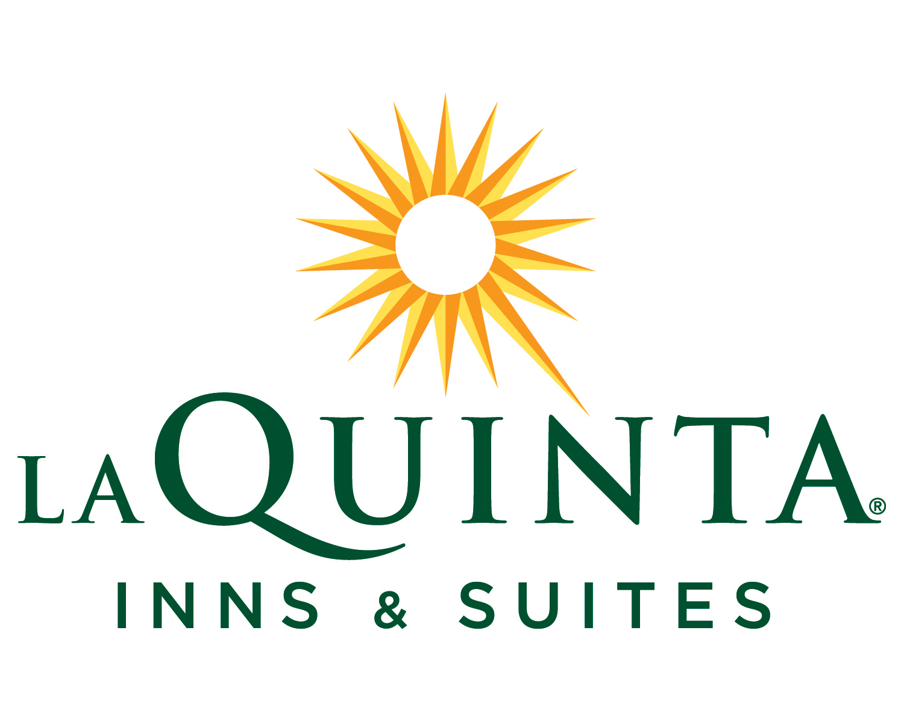
La Quinta Inn & Suites New Haven
400 Sargent Drive
New Haven, CT 06511
(203) 562-1111
RAMESH, NAGESH
48 N.SYCAMORE ST.
MACUNGIE, PA 18062
Company: L
Folio#: 204816514
Room: 315
Arrival: 09/01/08
Departure: 09/06/08
Rate: $148.00
Returns Club No:
Voucher/Ship/PO:

Trans# Date Description Charges Payments Balance

151563 09/01/2008 Rm: 506 Best Avail.Rate $148.00 $0.00 $148.00
151564 09/01/2008 TAX-OCCUPANCY-CITY $8.88 $0.00 $156.88
151565 09/01/2008 TAX-OCCUPANCY-ST $8.88 $0.00 $165.76
152327 09/02/2008 Rm: 506 Best Avail.Rate $148.00 $0.00 $313.76
152328 09/02/2008 TAX-OCCUPANCY-CITY $8.88 $0.00 $322.64
152329 09/02/2008 TAX-OCCUPANCY-ST $8.88 $0.00 $331.52
153011 09/03/2008 Rm: 506 Best Avail.Rate $148.00 $0.00 $479.52
153012 09/03/2008 TAX-OCCUPANCY-CITY $8.88 $0.00 $488.40
153013 09/03/2008 TAX-OCCUPANCY-ST $8.88 $0.00 $497.28
153066 09/04/2008 Rm: 506 Best Avail.Rate $148.00 $0.00 $645.28
153067 09/04/2008 TAX-OCCUPANCY-CITY $8.88 $0.00 $654.16
153068 09/04/2008 TAX-OCCUPANCY-ST $8.88 $0.00 $663.04
153112 09/05/2008 Rm: 506 Best Avail.Rate $148.00 $0.00 $811.04
153113 09/05/2008 TAX-OCCUPANCY-CITY $8.88 $0.00 $819.92
153114 09/05/2008 TAX-OCCUPANCY-ST $8.88 $0.00 $828.80
153199 09/06/2008 Rm: 506 Best Avail.Rate $148.00 $0.00 $976.80
153200 09/06/2008 TAX-OCCUPANCY-CITY $8.88 $0.00 $985.68
153201 09/06/2008 TAX-OCCUPANCY-ST $8.88 $0.00 $994.56

Balance: $994.56

Method of Pay: Cash

Signature

THANK YOU
WE APPRECIATE YOUR BUSINESS

